### 

### Semester Two Examination, 2020

### Question/Answer booklet

# MATHEMATICS METHODS

**UNIT 3 & 4**

## Section Two:

## Calculator-assumed

|  |  |
| --- | --- |
| **Your Name:** |  |
| **Your Teacher’s Name:** |  |

## Time allowed for this section

Reading time before commencing work: ten minutes

Working time: one hundred minutes

## Materials required/recommended for this section

***To be provided by the supervisor***

This Question/Answer booklet

Formula sheet (retained from Section One)

***To be provided by the candidate***

Standard items: pens (blue/black preferred), pencils (including coloured), sharpener, correction fluid/tape, eraser, ruler, highlighters

Special items: drawing instruments, templates, notes on two unfolded sheets of A4 paper, and up to three calculators approved for use in this examination

## Important note to candidates

No other items may be taken into the examination room. It is **your** responsibility to ensure that you do not have any unauthorised material. If you have any unauthorised material with you, hand it to the supervisor **before** reading any further.

|  |  |  |  |  |  |
| --- | --- | --- | --- | --- | --- |
| Question | Marks | Max | Question | Mark | Max |
| 8 |  | 6 | 13 |  | 10 |
| 9 |  | 9 | 14 |  | 11 |
| 10 |  | 9 | 15 |  | 10 |
| 11 |  | 5 | 16 |  | 10 |
| 12 |  | 12 | 17 |  | 12 |

**Structure of this paper**

|  |  |  |  |  |  |
| --- | --- | --- | --- | --- | --- |
| Section | Number of questions available | Number of questions to be answered | Working time (minutes) | Marks available | Percentage of examination |
| Section One:  Calculator-free | 7 | 7 | 50 | 50 | 35 |
| Section Two:  Calculator-assumed | 10 | 10 | 100 | 94 | 65 |
|  |  |  |  | **Total** | 100 |

**Instructions to candidates**

1. The rules for the conduct of the Western Australian Certificate of Education ATAR course examinations are detailed in the *Year 12 Information Handbook 2019*. Sitting this examination implies that you agree to abide by these rules.
2. Write your answers in this Question/Answer booklet.
3. You must be careful to confine your answers to the specific questions asked and to follow any instructions that are specific to a particular question.
4. Additional pages for the use of planning your answer to a question or continuing your answer to a question have been provided at the end of this Question/Answer booklet. If you use the space to continue an answer, indicate in the original answer space where the answer is continued, i.e. give the page number.
5. **Show all your working clearly.**Your working should be in sufficient detail to allow your answers to be checked readily and for marks to be awarded for reasoning. Incorrect answers given without supporting reasoning cannot be allocated any marks. For any question or part question worth more than two marks, valid working or justification is required to receive full marks. If you repeat any question, ensure that you cancel the answer you do not wish to have marked.
6. It is recommended that you **do not use pencil**, except in diagrams.
7. The Formula sheet is **not** to be handed in with your Question/Answer booklet.

**Section One: Calculator-assumed (94 Marks)**

This section has **ten** questions. Answer **all** questions. Write your answers in the spaces provided.

Spare pages are included at the end of this booklet. They can be used for planning your responses and/or as additional space if required to continue an answer.

● Planning: If you use the spare pages for planning, indicate this clearly at the top of the page.

● Continuing an answer: If you need to use the space to continue an answer, indicate in the original answer space where the answer is continued, i.e. give the page number. Fill in the number of the question that you are continuing to answer at the top of the page.

Working time: 100 minutes.

**Question 8 (6 marks)**

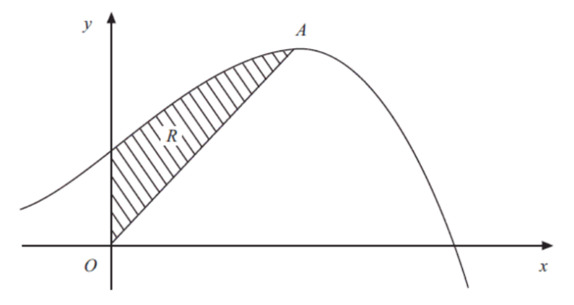The diagram shows part of the curve with equation $y=10+8x+x^{2}-x^{3}$ and a maximum turning point at $A.$ The region $R$ is bounded by the curve, the $y$– axis and the line from $O$ to $A$, where $O$ is the origin.

1. Using calculus, determine the coordinates of $A$. (3 marks)
2. Hence, find the exact area of $R$. (3 marks)

**Question 9 (9 marks)**

Let $X$ be a random variable with PDF given by

$$f\left(x\right)=\left\{\begin{aligned}cx^{2} -1≤x≤1 \\ 0 otherwise\end{aligned}\right.$$

(a) Determine the constant $c$. (2 marks)

(b) Determine $E\left(X\right)$ and $Var\left(X\right).$ (5 marks)

(c) Determine $P(X≥\frac{1}{2})$ (2 marks)

**Question 10 (9 marks)**

In a game at the Royal Show a player will pay to get five attempts to throw a ball at a target to win a prize. Of the last 500 throws, 91 of them hit the target. Consider this rate as the average standard of the average player.

(a) If one player hits the target three or more times in their five throws, they win a major prize. Calculate the probability that a player will win a major prize. State the distribution used and round your answer to four decimal places. (3 marks)

(b) One day, the owner of the game has only five major prizes. If 120 people play his game on that day, calculate the probability that he will not have enough major prizes to give out on the day. State the distribution used and round your answer to four decimal places. (Note: a player only has one round of five attempts) (3 marks)

(c) On the same day as in (b) above, the owner promised his two children he would bring them back one major prize each from the prizes left over. Given the owner had enough prizes to give out on the day, calculate the probability that he cannot fulfill his promise. Show working and round your answer to four decimal places. (3 marks)

**Question 11 (5 marks)**

Given that $x$ and $y$ are legs of a right-angled triangle with hypotenuse 1, **using calculus**, determine the largest possible value of the perimeter $p$ of this triangle $.$

**Question 12 (12 marks)**

A disease is spreading through trees in a forest. The instantaneous rate of change of the number $N$ of trees infected with respect to time $t$ is $\frac{dN}{dt}=0.18N$ trees/year. At the beginning of 2020 it is estimated that 1500 trees are infected.

1. The formula below predicts the number $N$ of trees infected $t$ years after the beginning of 2020. Determine the values of $N_{0}$ and $k$. (2 marks)
$$N=N_{0}e^{kt}$$

2. Using the formula:

(i) Determine the number (to the nearest integer) of infected trees 10 years after the beginning of 2020. (1 mark)

(ii) Determine the time taken (in years, to 2 decimal places) for the number of infected trees to double. (2 marks)

1. Determine the **yearly percentage increase** in the number of infected trees (that is, the percentage by which the number of infected trees increases from the start of one year to the start of the next). Give your answer to 1 decimal place. (2 marks)

Environmental authorities consider introducing a program that involves spraying the forest with a treatment chemical, with the first treatment at the start of 2021. The spray has been shown to immediately

change the instantaneous rate of infected trees to a negative 5% of the population.

1. Determine the predicted number of infected trees at the start of 2025. (2 marks)
2. Since the start of the spraying, determine the time taken for the number of infected trees to halve in number. (3 marks)

**Question 13 (10 marks)**

A production company wants to determine how popular their film will be when it hits the box office. To do this they used 10 focus groups, each with 300 participants as samples. In the first of these focus groups 215 people liked the film and the remainder did not.

(a) State two ways that the production company could increase the accuracy of their sampling. (2 marks)

For the first focus group:

(b) Calculate the sample proportion of people who liked the film to four decimal places. (1 mark)

(c) Determine the 95% confidence interval for the proportion of people who liked the film to four decimal places. (3 marks)

(d) What is the margin of error of the 95% confidence interval? (2 marks)

(e) With an example calculation, comment on the relationship between confidence and margin of error. (2 marks)

**Question 14 (11 marks)**

The lengths of the needles of the Aleppo pine, in cm, are Normally distributed with mean $μ$. It is further known that 11.51% of these pine needles are shorter than 5.7 cm and 3.59% are longer than 9.8 cm.

(a) Represent the information above in the graph below. (3 marks)

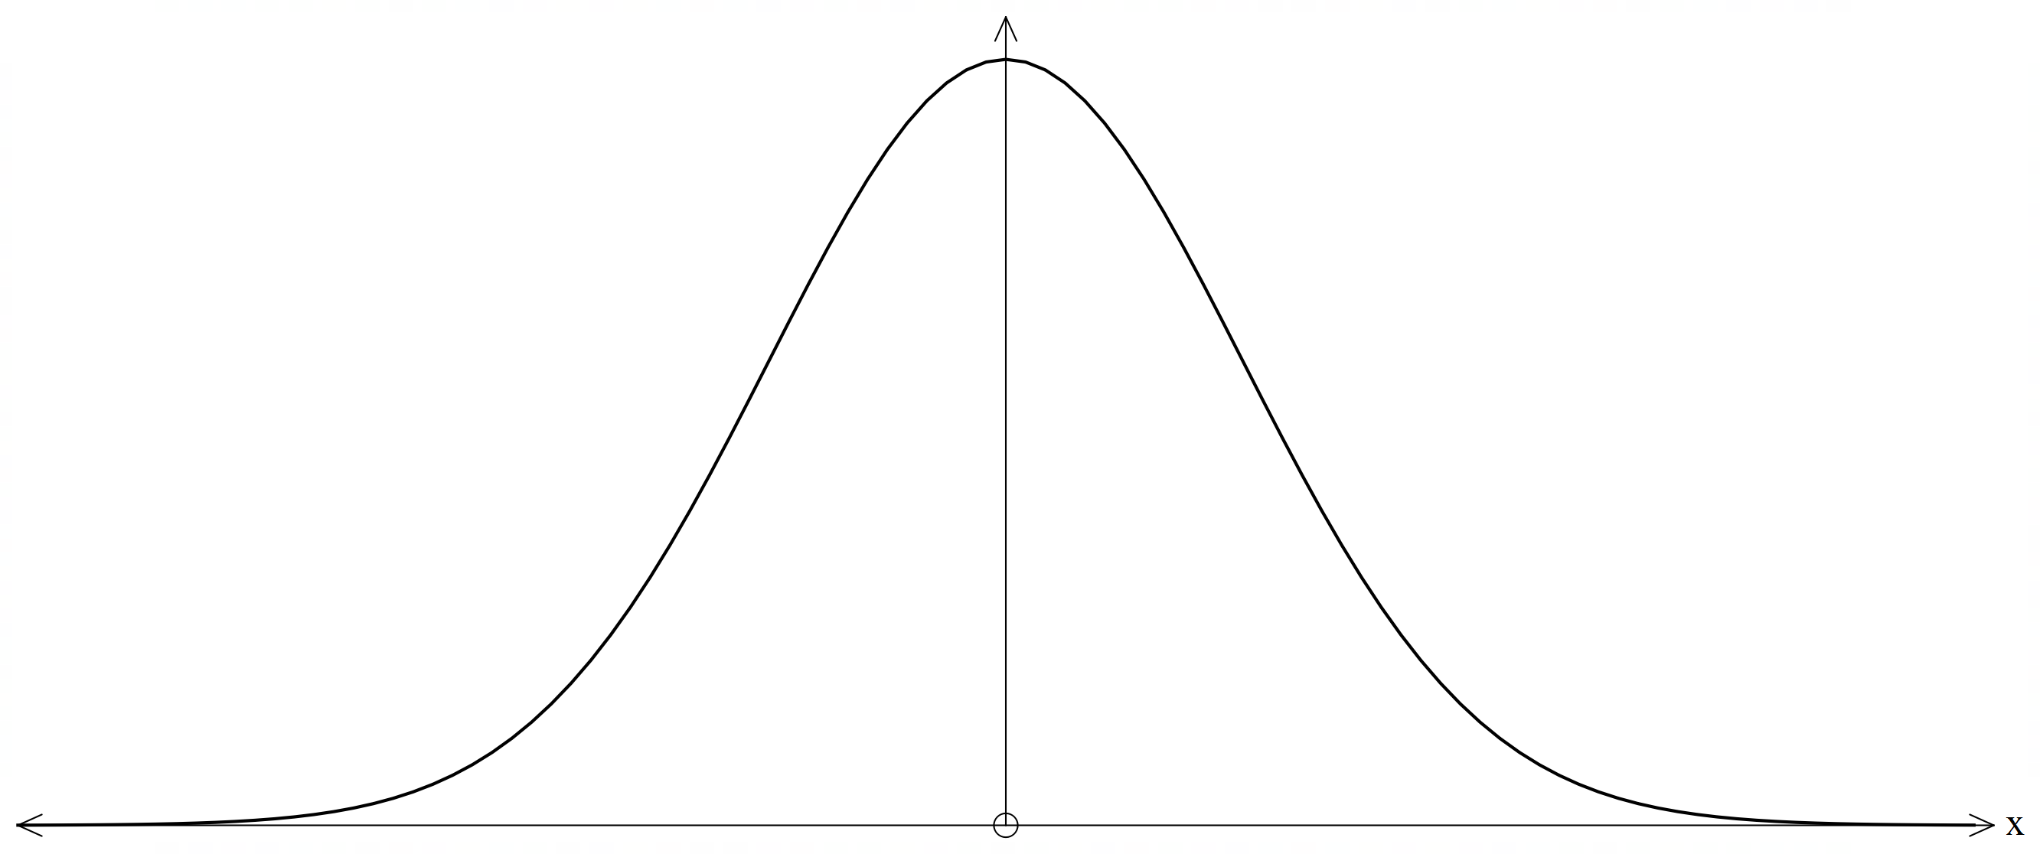

(b) Find the mean and standard deviation of the lengths of the pine needles. (4 marks)

(c) If 8 pine needles are selected, what is the probability that 5 of the needles will have measurements between the minimum and maximum lengths of the middle 40% of pine needle lengths? (4 marks)

**Question 15 (10 marks)**

A random sampling of a large collection of widely shared social media posts was conducted by a year twelve student at Perth Modern School. Out of 572 randomly selected posts, the student found that 293 contained false or misleading information.

1. Show how the student used the above information to calculate a 99% confidence interval for the population proportion to be (0.458,0.566)

(5 marks)

1. State whether each of the statements below is true or false **and give a reason** based on the information given above.
   1. If the student conducted random sampling repeatedly, then the true proportion of false or misleading information will fall between 0.458 and 0.566 ninety-nine percent of the time.

(1 mark)

* 1. The probability that the true proportion of false or misleading information falls between 0.458 and 0.566 is 0.99. (1 mark)

1. Another student is about to take a random sample of social media posts. The student is aiming for a margin of error of no more than 0.02 for a 99% confidence interval. How many posts should the student include in the sample? (3 marks)

**Question 16 (10 marks)**

A variable star is a type of star whose brightness fluctuates. One such star can reach its minimum and maximum brightness within the interval $0≤t≤6.1$, where $t$ is in days. The average brightness of the star is $C$ at $t=0$, which changes by $±a$. Note that $a$& $C$ are positive constants. The brightness of the star, after $t$ days, is given by:

$$B\left(t\right)=a\sin{\frac{2πt}{6.1}}+C$$

(a) Show the use of calculus techniques to determine the values of $t$ where the star will reach its minimum and maximum brightness, and state which value of $t$ will give this minimum and maximum. (4 marks)

(b) The star has a brightness of 4.9 at approximately $t= 0.79$. The rate of change in brightness for the star at this point is approximately 0.389. Determine the value of $a$ to 2 decimal places, and hence determine the function $B(t)$. (3 marks)

(c) Use the incremental formula at $t=1.2$ to estimate the change in brightness for a 3-hour change in time. (3 marks)

**Question 17 (12 marks)**

The following diagram shows the graph of $y=f(x)$, where $f\left(x\right)$ is a quarter circle for $1≤x≤2$ and a semicircle for $5≤x≤7.$

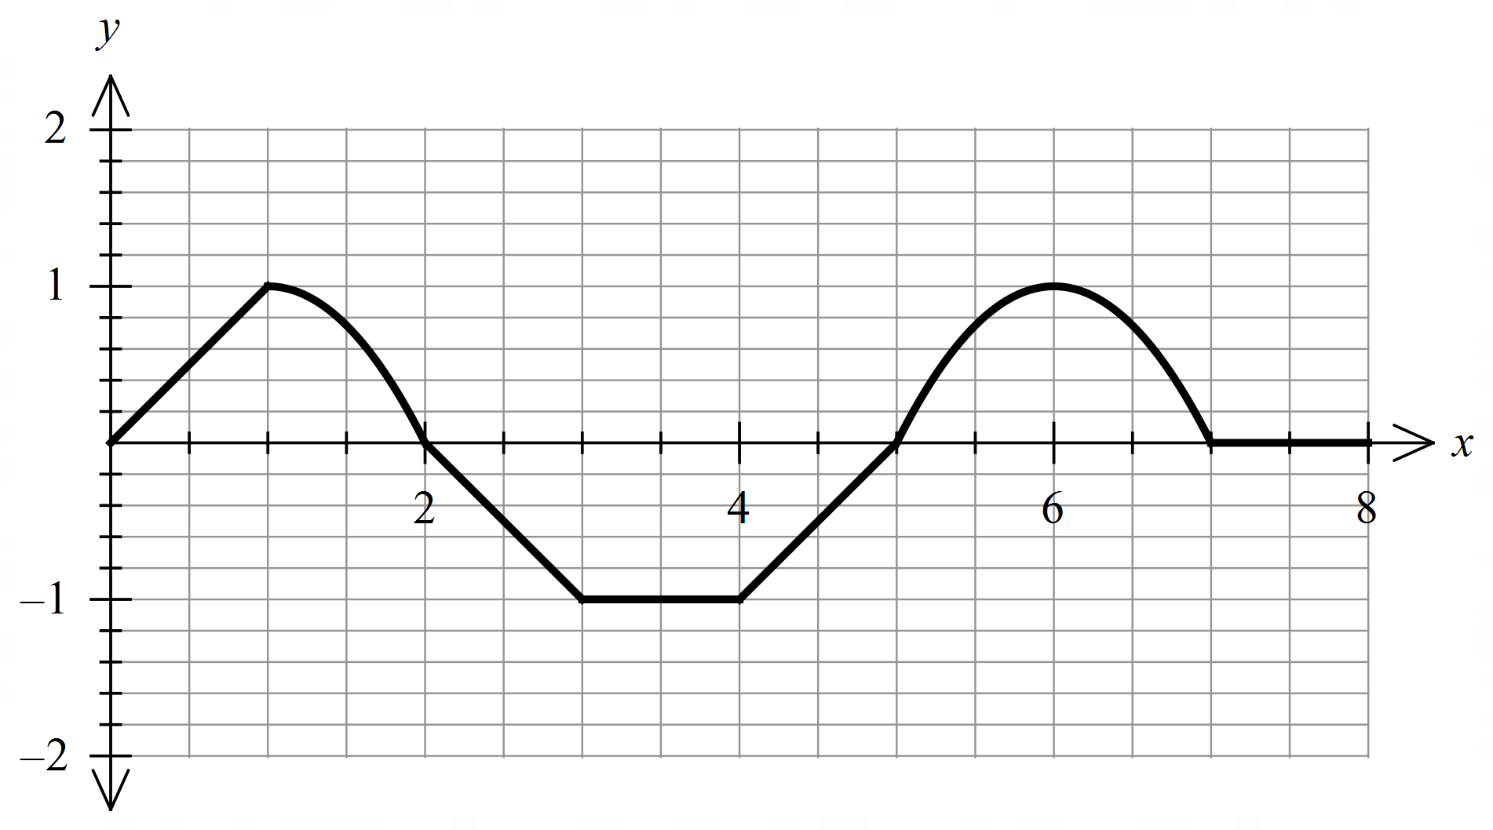

Let  equal the anti-derivative of , and , and that

$f\left(x\right)=0$ for $x≤0$ and $x≥7$.

(i) Determine the intervals where $F(x)$ is increasing and decreasing, respectively.

(2 marks)

(ii) Determine the intervals where $F(x)$ is concave up and concave down, respectively.

(2 marks)

(iii) Determine the value(s) of $x$ when $F\left(x\right)$ reaches the local maximum and local minimum, respectively. (2 marks)

Q17 cont-

(iv) Determine the exact value of $F(1)$. (2 marks)

(v) Determine the exact value of $F\left(7\right).$ (4 marks)

Additional working space

Question number: _______

Additional working space

Question number: ________

Additional working space

Question number: ________